Structured Literature Review
Loneliness and social wellbeing among older adults
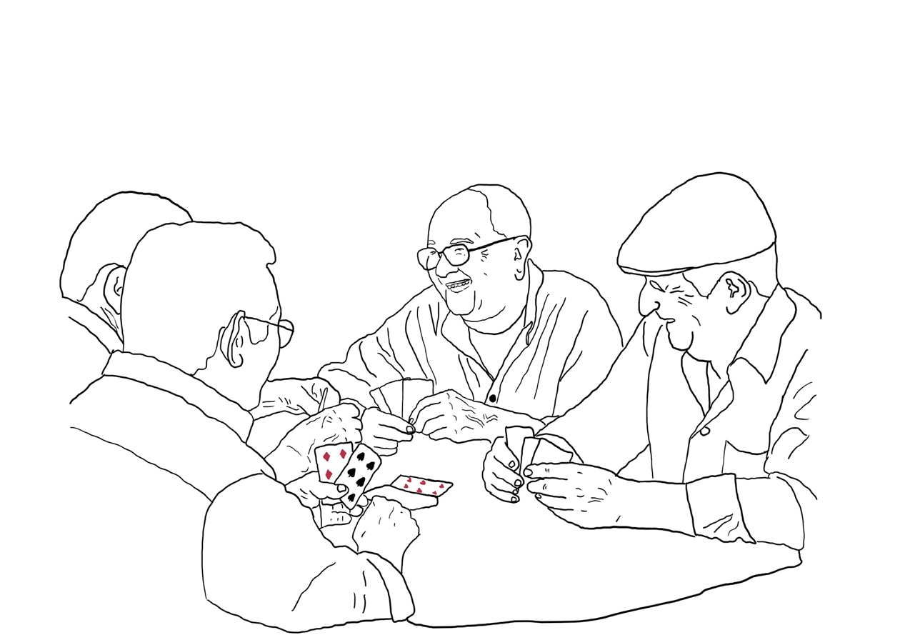

Research question:
How can loneliness within the senior population be averted and in turn lead to a higher level of social well-being and quality of life?
Sub-questions:
- Which sociocultural and structural factors contribute to alleviating or exacerbating loneliness among older adults?
- How can cross-cultural perspectives inform design strategies to create supportive environments for the social wellbeing among older adults?

Abstract
To excaberate and to early prevent loneliness among older adults previous studies on the related topic in different sociocultural and cross-cultural can be learned from when formulating different potentialities. We conducted a literature review study examining 13 peer reviewed articles retrieved from SCOPUS, we then curated a search string and followed up with a PRISMA flowchart. The primary results shows that loneliness is multidimensional with a variety of factors playing a central part in alleviating and exacerbating loneliness among elderly adults. Such as mobility barriers, lack of social infrastructure, gendered patterns and well-fare systems. While cross-cultural perspectives highlights cultural identity and beloning as central for social well-being, along with cultural dissonance, language barriers, family structure shifts and demographic conditions as factors for hightened loneliness.

Key words:
Human centered, Social wellbeing, loneliness, social isolation, innovation, design, cross-
cultural perspectives, inclusion, strengthening communities

Table of contents
Contents
Introduction 1
Review Design and Methodology 1
Literature Search and Selection Process 1
The use of AI 1
Research Questions 2
Comparatives analyze process of information 2
Copywriting and material production 2
Help in structure & design 2
PRISMA Flowchart 3
Key findings 4
Overview of included studies 4
Sociocultural and structural dimensions 4
Cross-cultural perspectives and design implications 5
Patterns, trends, and contradictions 5
Synthesis 6
Discussion and conclusion 6
Which sociocultural and structural factors contribute to alleviating or exacerbating loneliness among older adults? 6
How can cross-cultural perspectives inform design strategies — to create supportive environments for the social wellbeing among older adults? 8
Discussion 10
The limitations 12
References 13
Appendix 15
Individual contribution – Tove 15
Individual contribution – Joel 15
Source information 16

Introduction
Loneliness within the community of elders, is a widely spread complex issue in which among and throughout different cultures and communities is being tackled differently. In this literature review we are going to look further into what ways loneliness shapes the social well-being and quality of life among retired elderly citizens. While also looking further into which sociocultural and structural factors contribute to alleviating or exacerbating loneliness among older adults in different countries and contexts. With the stated research questions above we are also going to view the aspects of cross-cultural perspectives that possibly could inform design strategies to create supportive environments for the social well-being among older retired citizens. To essentially situate ourselves and our change agency to propose potential change.

As stated above, review we are going to examine on the different realities for retired elders while comparing their different cultural context. Continuing, a description of the term “cultures” will be of value when exploring our research questions further. Alongside with Koeber and Kluckhohn (1952, cited by Jenks 2004), and how they describe culture through its aspects of traditional ideas (specifically their attached values), cultures may be considered as products of action, as well as conditioning elements for further action. With that we will specifically aim for the relevance of different habits, that is cultivated within and throughout certain practices related to e.g religion, place-specific privileges, traditions and heritage, to later propose further action and change.

Through loneliness among elderly citizens is a complex issue found in countries and communities all over the world, we have found under-searched areas in which could invite researchers to investigate further. For instance, several of our chosen studies discuss sociocultural and structural aspects in relation to loneliness among the elder population, but few connects those to practical strategies for future change. While there is always a possibility for a deeper and broader literature study if we had gone about the search process in different ways. For example, if we had gone deeper into the different sociocultural contexts, emphasizing the review more deeply and on a quantitively scope, regarding the key factors, we might have been able to provide more statistically strengthen results.

Gaps we were addressing and why

Review Design and Methodology

Literature Search and Selection Process
A structured literature search was conducted in the Scopus database to identify relevant publications addressing loneliness, social wellbeing, and quality of life among older adults. The search strategy followed a systematic refinement process designed to balance scope and specificity.
The initial search query combined the terms elderly and loneliness, yielding 5,087 results. To ensure academic reliability, only peer-reviewed journal articles, conference papers, and book chapters were included. Further refinements were applied by limiting the search to English language publications within the fields of Social Sciences, Psychology, Nursing, Multidisciplinary, and Decision Sciences. This resulted in 2,356 records.
To capture a comprehensive understanding of the topic, a broad set of keywords related to ageing, wellbeing, and social relations was applied, including loneliness, aging, social isolation, social support, quality of life, mental health, older adults, social participation, and social connectedness, among others. After these filters, 2,008 publications remained. The results were then further refined by excluding the Nursing subject area and limiting the source type to journals, conference proceedings, and books, leaving 1,326 sources.
Recognizing the importance of cultural and cross-cultural perspectives for the study’s third research question, an additional search term (cultur*) was incorporated. This reduced the dataset to 121 publications, which were subsequently screened for relevance. Titles were reviewed to assess their connection to the research aim — examining how loneliness shapes social wellbeing and quality of life among older adults — and to the sub-questions focusing on sociocultural, structural, and cross-cultural factors.
After title screening, 76 studies were selected for abstract review. Abstracts were then analyzed to determine conceptual and methodological relevance. Studies were included if they (1) focused on older adults, (2) examined loneliness or social isolation in relation to wellbeing or quality of life, and (3) discussed sociocultural or structural influences. This process resulted in a final selection of 27 publications for in-depth analysis.
Through this multi-stage selection process, the final dataset ensured both empirical diversity and conceptual depth, reflecting a balanced representation of theoretical, quantitative, and qualitative contributions relevant to the research questions.

The use of AI
In this section we aim to present the why and how regarding our use of artificial intelligence (ChatGPT 5.0).

Research Questions
Mainly we used AI to create our initial research questions as well as the initial sub-questions. After refining with secondary prompts, we received these questions;
RQ: How does loneliness affect the social health and quality of life among older adults? Sub Question #1: Which sociocultural and structural factors contribute to alleviating or exacerbating loneliness among older adults in Western contexts?
Sub Question #2: How do cross-cultural perspectives on aging and intergenerational relations inform strategies to address social isolation among older adults in different societies?
After working with these initial questions for a while, we realized that we needed to be more specific in relation to some questions, to be able to conduct the study we wanted. We changed the initial RQ to the one we have today, as well as changing the secondary sub question to the one in our finalized review. The first sub-question was kept as it was written originally.

Comparatives analyze process of information
We have also been using AI to view similarities between our findings. For a more efficient and in-depth study we wanted to use AI to compare findings from different studies and create a more fine-tuned overview. This helped us in working with the findings in a structured and iterative way, creating a solid foundation for which we could address our research questions and formulate our findings.

Copywriting and material production
For some parts we used AI to create initial paragraphs of text for certain sections, which we then reworked. This was a process we implemented to help us in maintaining a good flow in writing our review, saving us time in pondering on how to begin certain sections.

Help in structure & design
Lastly, we used AI to help us with structuring and smaller design choices. For example, how to properly write footnotes, page header information, how to create the first page and information below the research questions as well as how to formulate a good table of contents. Additionally, we used Zotero when creating our reference list.

PRISMA Flowchart
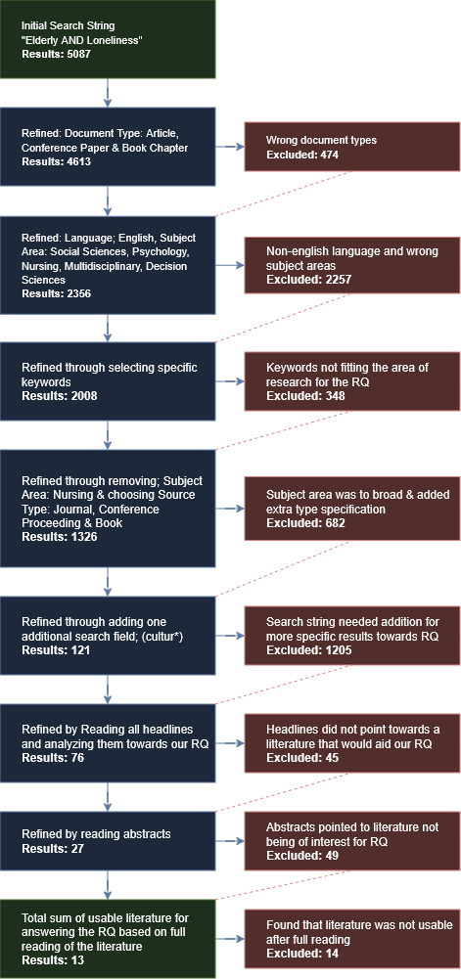

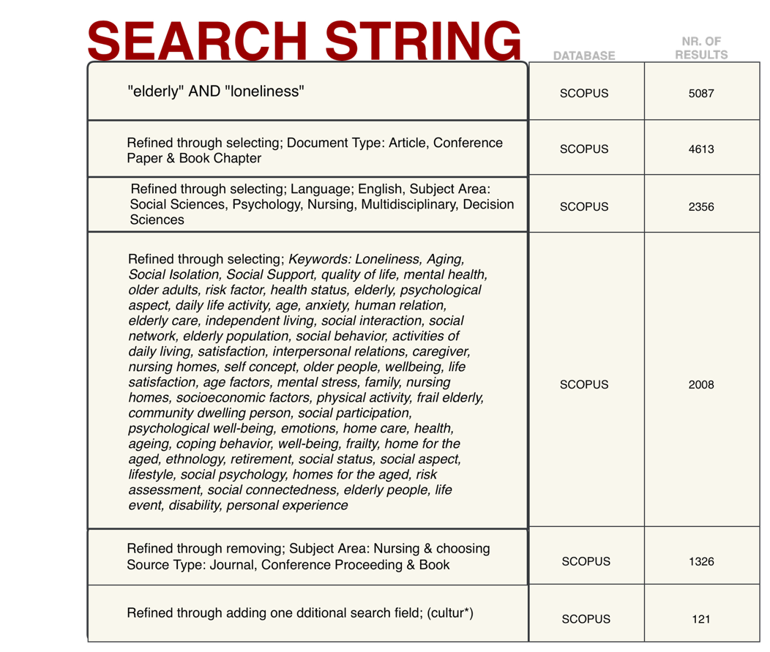

Key findings

Overview of included studies
We have partaken in literature that spans between 2004 and 2024, comprising 27 peer-reviewed studies found via the Scopus database. The majority are quantitative or mixed-method analyses that are complemented by qualitative and ethnographic works. Geographically these studies cover a wide range of regions across the World, spanning from Europe to Oceania. It aims to represent both Western and non-Western perspectives regarding the question of social wellbeing within the elderly Community. Sample sizes within studies vary from small qualitative studies involving as Little as 20-40 participants to large scale national surveys with several thousands of respondents.
Together, these studies aim to explore how loneliness interacts with sociocultural, structural and cultural-contextual factors and how it shapes the wellbeing and quality of Life in older adults.

Sociocultural and structural dimensions
Across our findings, loneliness among older adults is identified as a multidimensional concept. It is often composed of isolation and emotional loneliness (Frantál et al., 2020). Common predictors for this include age, gender, education, income and social participation. It is also found that declining health, limited mobility and accessibility as well as personal financial limitations consistently correlate with a reported higher loneliness. In comparison to this, social and cultural participation in various forms, aid in preventing loneliness.
In the studies we have reviewed there is also factors such as LGBTQ, gender differences, Nationwide political implementations of the welfare state and its effect on the individuals’ financial limitations that can either alleviate or exacerbate the individual’s wellbeing and quality of Life.
In conclusion to these findings, we argue that it indicates that loneliness is shaped not only by personal circumstances but in a more complex and multidimensional way, containing several different factors that in turn affect individuals lives and social wellbeing.

Cross-cultural perspectives and design implications
In regard to cultural variations and regional differences the studies we have taken part of reveal that cultural values, family norms and social expectations heavily influence how ageing and loneliness are experienced.
For example, in Iran change in family structures and urbanization show signs of reducing opportunities for intergenerational social Contact and social participation (Rezaeipandari et al., 2020). In Uganda, the socioeconomic and infrastructural limitations, particularly regarding income and transport, restrict social engagement (Nzabona et al., 2016). In contrast to his, Māori elders in New Zealand Point to cultural identity, language and shared traditions as Foundations for the sense of belonging and social wellbeing. As a final example of cross-cultural perspectives, we found that among Chinese immigrants in New Zealand, cultural and language barriers deepen the sense of loneliness, showing a need for culturally responsive Community design (Morgan et al., 2021).
The overall picture painted by these studies suggest that inclusive and culturally grounded Environments are vital to enable social connectedness. Design literature (Emlet & Moceri, 2012, as cited in Morgan, 2021) reinforces this by proposing co-design approaches which can directly involve the elderly population in shaping environments that can alleviate loneliness and lack of social connectedness.

Patterns, trends, and contradictions
- Consistent pattern: The studies argue that loneliness is found in the interaction between individual vulnerability and structural inequality. Factors directly affecting this is economic insecurity, constraints in mobility and lack of including social spaces.
- Emerging trend: We argue that there is a shift in viewing loneliness as a personal circumstantial phenomenon to a multidimensional concept including both financial, social, environmental and cultural aspects.
- Cross-cultural insight: Cultural identity and belonging can either alleviate or exacerbate the feeling of loneliness, all depending on its prevalence. A lack of cultural belonging can lead to loneliness and a decline in social wellbeing and a strong cultural belonging may alleviate loneliness and create a strong sense of Community and togetherness.
- Main contradiction: Welfare systems and institutional care are factors that can alleviate financial restraints and provide a solid Foundation for good Health within the elderly population. It may however also risk reducing Community engagement if not balanced with opportunities for participation.

Synthesis
A red thread found in reviewing the studies is that the idea of social wellbeing in later Life is a concept that is co-produced through a variety of factors, such as social participation, environmental accessibility, cultural meaning and inclusion as well as personal financial safety, maintaining Health and mobility.

To build inclusive, connected, and culturally sensitive Environments that may enhance wellbeing for older citizens, we argue that future research and policy must integrate these factors in a cross-disciplinary perspective and implement empirical insights into Concrete design strategies. This is vital for tackling this issue in a multidimensional way and creating ways for alleviating loneliness within the senior population, in turn creating a higher quality of Life and greater sense of wellbeing.

Discussion and conclusion

Which sociocultural and structural factors contribute to alleviating or exacerbating loneliness among older adults?
Socioeconomic status refers to the social standing or class of an individual or group and is commonly measured as a combination of education, income, and occupation (European Commission, n.d.). To approach the question of how loneliness shapes the social wellbeing and quality of life among older adults, answering how the sociocultural and structural factors affect the concept of loneliness is of great importance. This is due to the factors that make or break the wellbeing of older adults. For example, can a robust social network alleviate the feeling of loneliness? Do financial situations affect the wellbeing of the individual? How important is the difference in access to daily activities, cultural events and to be able to move between rural and urban areas?

Frantál et al. (2020) provide insights into these questions presenting empirical evidence on how the sociocultural and structural factors influence the loneliness of senior citizens and older adults. Their study identified socio-spatial isolation as a multidimensional phenomenon comprised of passivity, isolation and loneliness. The authors of the study found that age, gender and educational levels significantly predicted the level of isolation, while different income levels and participation in leisure and/or sporting activities were linked to passivity. Also, women in particular who had raised several children were more likely to experience loneliness in later life when contact with the family had decreased.

The research demonstrated how social and cultural participation can alleviate isolation. As stated, “trips to nature, sport activities, cultural events, get together with friends and visits to restaurants” all had a positive impact on reducing loneliness (Frantál et al., 2020, p. 334). Furthermore, structural constraints, both exterior and personal, such as health problems, financial limitations and restricted transport mobility were reported as the main barriers to social engagement.

Hansen and Slagsvold (2016) reinforces previous research showing that, in their case, older Eastern Europeans are particularly vulnerable to loneliness due to socioeconomic status, health and social networks and in turn their opportunity for social participation and experiencing rewarding social relationships. This is however not excluded to this particular group of individuals; it is only more prevalent within that context. They argue that central to this discussion is the role and scope of the welfare state where two contradictory perspectives can be put forward. Either generous welfare states may promote better condition or the crowding-out hypothesis, warns that strong welfare states may decrease civic engagement by taking over tasks traditionally carried out by families, local communities, and social networks.

According to the authors empirical evidence generally supports the first perspective. Both current and prior research associates a high national level of welfare with less loneliness among the elderly. This can be seen as an affirmation of the concept of, for example, individual financial restraints or lack of access to free healthcare being a factor that exacerbates loneliness as these factors contributes to the lack of opportunities for the elderly citizens.

Another factor, which Büssing et al. (2021) highlights, is the importance of existential and spiritual needs being met as they also are determinants for wellbeing in the later stages of life for the elderly. They found that unmet spiritual and relational needs are closely linked to loneliness and declining psychological wellbeing due to its loss of connectedness among things. Also, as we have read in previous studies, they found that participation, inclusion and opportunities to contribute to others lives in a meaningful way strengthen both the spiritual ad psychological wellbeing, in turn increasing the overall wellbeing in later life.
In addition to what we have reviewed so far there is another interesting factor that may play a significant role in shaping the wellbeing of elderly citizens, namely, the LGBTQ factor among the elderly population. McGovern et al. (2016) demonstrate that community-based LGBTQ senior centers significantly alleviate loneliness through social inclusion, acceptance, and the creation of “families of choice.” According to their study many older LGBTQ adults face isolation due to stigma, rejection by family of origin and limited access to appropriate social service. In their study, they found that certain senior centers dedicated to this target demographic create a sense of belonging and mutual care, transcending the traditional concept of family and are able to aid in reducing social isolation. Therefore, it is also paramount to view all groups of the elderly in all variations of demographics, both socially, culturally and sexual-oriented when addressing the issue of wellbeing in later life.
Furthermore, an important factor that may be beneficial to study in regard to wellbeing in later stages of life is the concept of physical environments. Luo and Han (2025) identify physical environments as decisive structural factors affecting loneliness and subjective wellbeing. In their study, using a large-scale sample from China, they found that environmental safety and access to public facilities significantly predicted wellbeing, in large by enabling mobility. They argue that improving environmental conditions may alleviate loneliness and improve quality of life for the elderly population.
Viewing these studies and the conclusions that they show and discuss cements the concept of socio-economic and socio-cultural factors as vital instruments in analyzing the effect on what creates loneliness and in turn how to prevent it. This can then be used as a stepping board to address the main question of in what ways does loneliness shape the social wellbeing and quality of life among older adults.
As we have read it is foremost important to alleviate the effects of financial restraints for the elderly population, create meaningful spaces for senior citizens to partake in rewarding and stimulating social interactions as well as making sure that the physical boundaries are not prevalent to the extent that it hinders their participation in outdoor activities in all forms and shapes.

How can cross-cultural perspectives inform design strategies — to create supportive environments for the social wellbeing among older adults?
In an increasingly more distant yet interconnected world, the experience of loneliness and well-being differs among older adults all around the world. Where the aspect of aging and in relation to togetherness and loneliness carries a diverse set of socio-cultural aspects that are important to understand and respect. Along with an older population that lives longer, the need for well-formulated and designed environments that supports social well-being across different cultural settings becomes more visible. It is then of value to examine how cross-cultural perspectives on aging, loneliness, belonging and participation later in life differs across cultural settings as well as site-and person specific aspects. And how these aspects can be understood and utilized in the continuation of co-designing a diverse framework that essentially could offer higher levels of community participation, togetherness and well-being across different elderly communities.
Social well-being defined through participation, belonging and meaningful connection is highly influenced on how older adults perceive community and identity within their specific cultural contexts. Where studies from Iran, New Zealand, Uganda, Denmark and immigrant communities each reveal distinct ways that culture shapes experiences of loneliness and social participation. Drawing on these cross-cultural perspectives, this research will further explore how design strategies can be informed by cultural understanding to create supportive environments that enhance the social well-being of older adults.

As stated above, the meaning of well-being later in life varies significantly, revealing the importance of culturally grounded approaches to design to comprehend system complexities with its communities.
In Iran, the authors Rezaeipandari et al. (2020) sheds lights onto aspects of loneliness linked to changes in family structures and how the shift reduces opportunities for social participation and togetherness. Making the need for environments that encourages community participation and intergenerational interaction visible. While in contrast, Morgan et al. (2021) and the Māori participants in New Zealand paints a picture on how cultural identity and belonging are central for the well-being of the community. Specifically mentioning language, heritage and cultural traditions as a core for the collective, to maintain and expand social value beyond their “four walls” of their homes. While carrying knowledge of language and culture, or the lack thereof, as mentioned by Chinese immigrants in New Zealand, where feelings of disconnection are more often rooted in cultural dissonance and language barriers. Reinforcing sense of belonging and value of culturally responsive and inclusive design choices within the community of elders.
Similarly, findings from the study made by Nzabona et al. (2016) in Uganda emphasizes socioeconomic and demographic factors as reason for social isolation, highlighting the importance of accessible community infrastructure.

Emlet and Moceri (2012, as cited by Morgan et al., 2021) describes inclusive spaces with certain aspects that are important for successful aging, where features of the built environment can be utilized to create and/or support barriers to social connectedness. To build on that further, examples of important structures can be accessible public transport to expand the boarders of social belonging beyond site-specific aspects. Nonetheless, as a core in the refinement of supportive environments it is of value to add that social connectedness through one-on-one personal contact, as well as group activities strengthens the aspect of belonging and togetherness.

In addition, one of the aspects that is concluded by Morgan et al. (2021) and the Māori participants, is that volunteering could act as a bridge to community engagement, making use of carried value and knowledge within a broader social scene. Along with that, community groups and volunteering, grounded in culture-specific practices as valuables to social integration and belongingness. For example, many Māori participants stressed the importance of the kaumātua (Māori elder) – day program, simply because it was formulated and designed around shared cultural value and practices of prayer and sharing of food in a community setting (Morgan et al., 2021). In conjunction, the authors Lay-Yee et al. (2022) and Kasakura et al. (2025) proposes similar findings that strengthens the notion of social well-being being interlinked with having a purpose, peer and community interventions. Where well-being among the elders highlights family-ties (related by blood or not), accommodation of cultures and traditions of relevance for improving mental health, resilience and a strong sense of well-being.

While trying to grasp the complexity of the topic of aging and loneliness, the Danish discourse by Mikkelsen (2016) gives us a different perspective of “successful aging”. Where the strong emphasis on social engagement and a broad social network may unintentionally create or even worsen loneliness among older adults. Where the emphasis on social activity as a main marker of well-being and belongingness, through an anthropology and psychoanalytic viewpoint could risk pathologizing solitude for the Danish elder. Where the only way to measure social well-being and value creation is through an active social life and relations to others. The author proposes that research should move beyond seeing loneliness as solely a symptom of social failure, and to instead explore solitude as a meaningful, and even a necessity dimension of human life and meaningful existence.

As the cross-cultural perspectives has been collected and summarized, the aspect of “what if” emerges. What if the collected knowledge could inform design strategies to create and refine environments for the social well-being of older adults? What could that look like? And how could it be suitable cross-cultures, communities and people?

The authors Wiles et al. (2019) allows us to view a befriending service that acts as a platform for social synergy and emergence, to enable community participation and relation making. They identified five important characterizes for an ideal service intervention as; supported opportunities for getting out, genuine and reciprocal relationships, reliability, visitor characteristics and connecting people to their culture. Along with Olfat (2025) it is made clear that designing supportive environments and interventions that cater to the psychological and physiological needs of older adults could enhance their sense of comfort, well-being and belonging.
With that, weaving the social fabric together with interventions for social participation and well-being, it is of value to do so with a diverse set of tools to meet the diverse needs of the elderly throughout communities, places and spaces. To furthermore respect cultural diversity and heritage when exploring potential frameworks of design within the system of elderly and care. Where sense of belonging and social well-being is manifested within different aspects of one’s Identity and personal experiences.

Discussion
As a way into the discussion of our research and our findings, we need to situate ourselves as designers along with our agency within the concept of change. Dalladay-Simpson (2020, Para 10) gives a meaningful description of change agency in relation to the world we act in:

When we re-align parts of a system for positive impact, we haven’t just solved a problem, but have unlocked value and created new meaning. Even if only in a small way, we have changed the fabric of the world.

Co-creating meaning, value and well-being for older adults holds much space for transformation. Where aging as a contribution instead of aging as decline is key for understanding why and where the change needs to be applied. As a general synthesis loneliness is both individual and systemic, highly shaped by social roles, welfare systems and spatial design. Where social participation, belongingness equity and culturally responsive designs are key in the continuation and fostering of general well-being. Strategies must therefore integrate socioeconomic inclusion, mobility access and cultural belonging to aid and support ageing populations. With the gained knowledge the needs within our area of research are made visible and tangible, where environments need to be formulated to encourage community participation. Including spaces for cultural belonging and shared practices, such as sharing of technologies, food, tradition and heritage. Furthermore, it is crucial to include a well composed and accessible community infrastructure, with transportation as key to movability and local participation. Continuing though it is of importance to not solely measure well-being and value creation through an active social life as stated by Mikkelsen (2016), but to also explore solitude as a meaningful dimension of human life and continuance (especially considering our fast-paced societies nowadays).

Concluding the needs, and transforming them into actual potential action, a well-formulated design concept could be applied to various of places and spaces. Where the design could be used to formulate a tool-box or a recipe for co-creation together with older adults throughout communities. To explain further, Maziar et al. (2013) explains design and designers as becoming more relational and entangled in the lives of its collaborators and users. Shifting the roles of designers in relation to societal changes, to facilitators, mediators and change agents, to essentially bridge the gap between societal shifts and the needs of the people, while including them in the process of co-creating their livelihoods together.

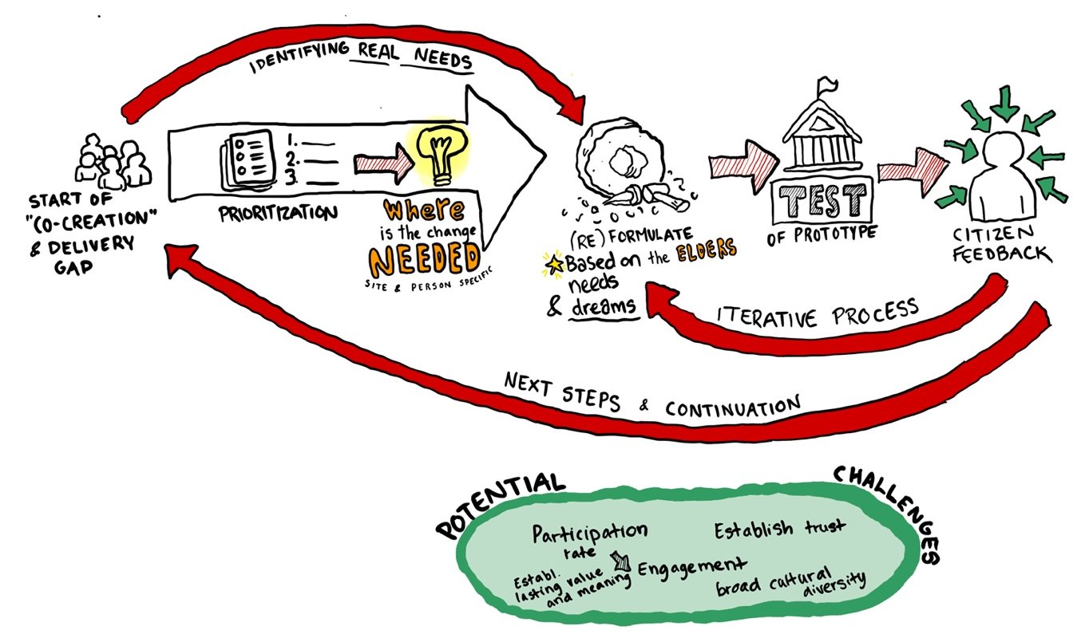

The image is meant to visualize the journey of co-creating new potentialities and livelihoods, and what the process could look like.

To understand the system and its complexities, as well as where to situate the proposed design and change. Designers need to learn about situated design and socially responsive design, and as Tham et al. (2019) explores it further, to pay attention to the relationships before intervening. To actively practice social acupuncture instead of designing for the symptoms, to essentially address the underlying causes.

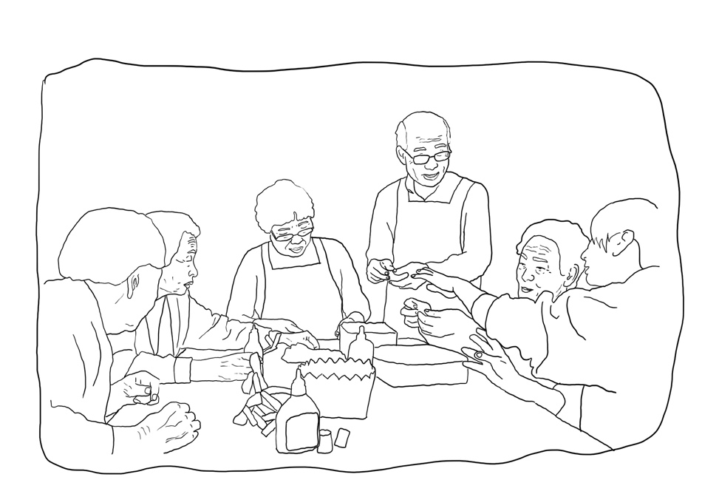

Examples of ”what if’s?” that could be implemented based on the research:

- Flexible cultural programming
- Intercultural gardens
- Community workshops & hybrid programs
- Community coordinators
- Cultural story archives
- Free access to public transport

The limitations
Nevertheless, as we conclude our research it is crucial to be skeptical towards our way of searching and finding the knowledge that we have gained. Where we in our search string actively chose to exclude psychology from our keywords in Scopus. It is worth contemplating on what could have been found if we had included it from the beginning, and how it may have influenced our results and conclusion. Since psychology and in relation to mental health is a key part in understanding the behavioral aspects, it could have offered us a richer understanding of human behavior as well as a more accurate understanding of the topic in itself. Going further into the limitations of this project it is important to mention that we could have gone about with the research in a more in-depth way, for example, if we had gone deeply into the cultural context, and had a broader scope of counties. The gained information could have informed the review more deeply and quantitively, to achieve statistically strengthened results.

The limitation of the reviewed literature allows us to comprehend that this field was limited by the scope and diversity of available studies. There are a lot of literature covering loneliness among elderly citizens, although not always with the same focus and intentions. However, we found that the literature scope is highly broad in terms of cultural diversity, where some are focused on specific countries, communities within the countries, regions and even parts of regions. Some on the one hand, analyzes a multitude of countries all at once. Though the common denominators shows that Western cultures and regions, as well as Indian and Chinese areas are largely and commonly covered, this, concluded based on the results our search gave us. We do, however, believe that our study convers the broad basics of the subject itself, highlighting important factors both in relation to cultural aspects. As well as the “what is” and “what is not” factors that alleviates or exacerbated loneliness among older adults.

In conjunction with the limitations stated above, there is a clear gap within our research that informs how design and design strategies are in cooperated into concrete design practices and planning. Where several of our studies discuss sociocultural and structural factors, but few connects these into actual practical strategies. Though this could have been investigated further and more thoroughly in the beginning of our search string, if we had added different key words and/or search areas that could be described by “design practices” AND/OR “systemic change” etc.

As this literature review is at its end, some questions is answered, and some remain.

Would it be possible to formulate a design recipe for co-creating new, socially responsive environments together with older adults?
And would it lead to a broader sense of well-being? And how can the design principles be implemented to a broader spectrum of diverse individuals, taking their heritage, practices, spaces and health-conditions into consideration?

References
- Büssing, A., Spalek, R., Pikuła, N. G., Frick, E., & Surzykiewicz, J. (2021). Spiritual needs of elderly. In A. Büssing et al. (Eds.), Spiritual Needs of Elderly. Springer Nature Switzerland. https://doi.org/10.1007/978-3-030-70139-0_26

- Dalladay-Simpson, J. (2020, March 7). How design shapes our systems of value and knowledge. Metadesigners (Medium). https://medium.com/metadesign-network/how-design-shapes-our-systems-of-value-and-knowledge-48bbe1607537

- European Commission. (n.d.). Socioeconomic status. Knowledge4Policy. https://knowledge4policy.ec.europa.eu/glossary-item/socioeconomic-status_en.

- Frantál, B., Klapka, P., & Nováková, E. (2020). When home becomes a cage: Daily activities, space-time constraints, isolation and the loneliness of older adults in urban environments. Moravian Geographical Reports, 28(4), 322–337. https://doi.org/10.2478/mgr-2020-0024.

- Hansen, T., & Slagsvold, B. (2016). Late-life loneliness in 11 European countries: Results from the Generations and Gender Survey. Social Indicators Research, 129, 445-464. https://doi.org/10.1007/s11205-015-1111-6.

- Jenks, C. (2004). Culture. Taylor & Francis Group.

- Kasakura, Y., Shae-Leigh V., & Nagesh P., (2025). “A Needs-Based Assessment of Older Immigrants Experiencing Loneliness and Social Isolation and the Effectiveness of Interventions Responding to the Identified Needs: An Umbrella Review and Research Update.” Journal of Gerontological Social Work 68(5): 585–601. doi:10.1080/01634372.2024.2425052.

- Lay-Yee, R., Milne, B. J., Wright-St Clair, V. A., Broad, J., Wilkinson, T., Connolly, M., Teh, R., et al. (2022). “Prevalence of Loneliness and Its Association With General and Health-Related Measures of Subjective Well-Being in a Longitudinal Bicultural Cohort of Older Adults in Advanced Age Living in New Zealand: LiLACS NZ” ed. Anna Zajacova. The Journals of Gerontology: Series B 77(10): 1904–15. doi:10.1093/geronb/gbac087.

- Luo, J., & Han, Z. (2025). Have a place to live? Study on the influence of the living environment on the subjective well-being of older adults. BMC Psychology, 13, 694. https://doi.org/10.1186/s40359-025-03007-1.

- McGovern, J., Brown, D., & Gasparro, V. (2016). Lessons learned from an LGBTQ senior center: A Bronx tale. Journal of Gerontological Social Work, 59(7–8), 496–511. https://doi.org/10.1080/01634372.2016.1255692.
- Morgan, T., Wiles, J., Park, H., Moeke-Maxwell, T., Dewes, O., Black, S., Williams, L., and Gott, M., (2021). “Social Connectedness: What Matters to Older People?” Ageing & Society 41(5): 1126–44. doi:10.1017/S0144686X1900165X.

- Mikkelsen, H. H., (2016). “Unthinkable Solitude: Successful Aging in Denmark Through the Lacanian Real.” Ethos 44(4): 448–63. doi:10.1111/etho.12144.

- Nzabona, A., Ntozi, J., & Rutaremwa, G., (2016). “Loneliness among Older Persons in Uganda: Examining Social, Economic and Demographic Risk Factors.” Ageing and Society 36(4): 860–88. doi:10.1017/S0144686X15000112.

- Olfat, M. (2025). “Exploring the Meaning of Home for the Older Adults: A Bibliometric Analysis of Environmental and Psychological Needs (1969–2023).” Journal of Aging Studies 73: 101332. doi:10.1016/j.jaging.2025.101332.

- Raein, M., Lundebye, A., Jones, H., “A Manifesto for Designing Together in the 21st Century.” https://www.academia.edu/15258101/A_Manifesto_for_Designing_Together_in_the_21st_Century (May 3, 2023).

- Rezaeipandari, H., Ravaei, J., Bahrevar, V., Mirrezaei, S., & Morowatisharifabad. M. A., (2020). “Social Participation and Loneliness among Older Adults in Yazd, Iran.” Health & Social Care in the Community 28(6): 2076–85. doi:10.1111/hsc.13018

- Tham, M., Ståhl, Å., & Hyltén-Cavallius, S., (2019). Oikology - Home Ecologics: A Book about Building and Home Making for Permaculture and for Making Our Home Together on Earth. Växjö: Linnaeus University Press.

- Wiles, J., Morgan, T., Moeke-Maxwell, T., Black, S., Park, H-J., Dewes, O., Williams, L. A., & Gott, M., (2019). “Befriending Services for Culturally Diverse Older People.” Journal of Gerontological Social Work 62(7): 776–93. doi:10.1080/01634372.2019.1640333.

Appendix

Individual contribution – Tove
The work overall on this Project has been a lot in cooperation with Joel and we have put a lot of time, blood and tears, into working together in real time, both on Place but also via Microsoft Teams.
My specific focus has been in relation to the second sub-question: How can cross-cultural perspectives inform design strategies to create supportive environments for the social wellbeing among older adults?
With that I have focused mostly on the cross-cultural perspectives and how they can inform design strategies. I have also focused more onto the “what if’s?”, I drew the visuals and the journey map to help me in the design thinking. Along with my Design + Change educational background I have focused a bit more into system complexities, maps and the emotional part of our project.

Individual contribution – Joel
The work overall on this Project has been a lot in cooperation with Tove and we have put a lot of time into working together in real time, both on Place but also via Microsoft Teams.

Regarding my specific focus, it was targeted at the first sub-question; "Which sociocultural and structural factors contribute to alleviating or exacerbating loneliness among older adults?".

By reviewing the literature targeting this question I was able to go in depth regarding different factors that played key roles in alleviating or exacerbating loneliness, what other conclusions the writers would argue on and more in depth regarding the implementation, or lack of, in terms of how the empirical data is translated into de facto solutions.

As coming from information architecture, I have also worked with the structuring of the Review in forms of typographic work and taxonomy, e.g. font sizes, headings, sub-headings, table of contents, headers and footers.

Source information

Source nr: | Country of origin: | Qualitative or Quantitative
1. | Germany, Poland and Italy | Mixed/quantitative
4. | Czech Republic | Qualitative/observational
5. | Multiple countries in Europe | Quantitative
7. | International Review | Mixed methods (Umbrella review)
8. | New Zealand | Quantitative
9. | China | Quantitative
10. | USA (Bronx, New York) | Qualitative
11. | New Zealand (Māori, Pacific, Asian and NZ European groups) | Qualitative
12. | Denmark | Qualitative
13. | Uganda | Quantitative
15. | North America & Europe (Multi-region) | Quantitative
17. | Iran | Quantitative
18. | New Zealand | Qualitative

